FUNDAMENTAL AERO EQUATIONS TO MEMORIZE

The equations given here are basic tools which will be used numerous times in Aero 315. You should commit them to memory as soon as they are covered in the syllabus. These equations are fair game for quizzes, etc. at any time after they are covered in class. Of course, you will also be expected to know and understand them for exams.

GR #1

P = ρ R T Perfect Gas Law (2.1)

q = ½ ρ V² Dynamic Pressure (3.5)

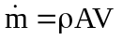 1-D Mass Flow (3.1)

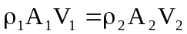 1-D Compressible Continuity Equation (3.2)

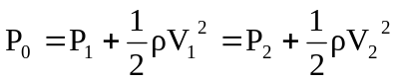 Bernoulli’s Equation (3.4)
Memorize the airspeed where compressible flow effects must be considered (330 ft/s or 100 m/s)

L = C_{L} q S Lift as a function of lift coefficient (4.4, 3.21)

D = C_{D} q S Drag as a function of drag coefficient (4.5, 3.22)

M = C_{M} q S c Pitching moment as a function of pitching moment coefficient (3.24)

AR =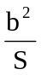 Aspect Ratio (4.2)

GR #2

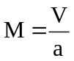 Mach Number (3.34)

C_{D} = C_{Do} + k C_{L}² Aircraft drag polar (4.15)

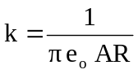 Aircraft “drag due to lift” factor (4.16)

P = T V Power relationship to thrust (5.24)

R = E V Range relationship to endurance (5.37)

Memorize the relationship between parasite and induced drag for all major performance objectives as well as where these relationships occur on the Thrust and Power charts.

